Wind
Wind- horizontal movement of air which is caused by differences in air pressure.
Air moves from HIGH PRESSURE to LOW PRESSURE! The differences in pressure are caused by uneven heating of the earth!
HOT AIR RISES=LOW PRESSURE
COLD AIR SINKS= HIGH PRESSURE
Wind direction- the direction that the wind is coming from
Example: the wind is coming from the west so the wind direction is WEST
Example 2: the wind is from the north so the wind direction is NORTH
Example 3: the wind is blowing to the east so the wind direction is WEST
Wind Speed-the rate at which wind moves in knots or mph
Large difference in air pressure= strong winds
Small difference in air pressure = weak winds
Example: Sea Breeze on a sunny summer day!
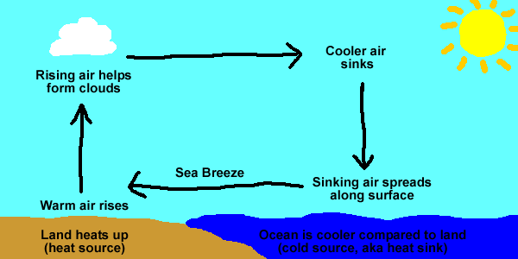
HIGH PRESSURE
LOW PRESSURE
NOTE: Winds appear to curve to the right in the northern hemisphere. This is caused by the earth’s rotation and is known as the Coriolis Effect
Wind Questions:
- What causes wind? ___________________________________________
- Hot air _______________ and cold air _____________________
- Hot air is associated with _____________________ pressure.
- Cold air is associated with ____________________ pressure.
- Explain the relationship between wind speed and differences in air pressure. (2 complete sentences)
_____________________________________________________________
_____________________________________________________________ _____________________________________________________________

- As air circulates this is known as what type of energy transfer?
  - Conduction
  - Convection
  - Radiation

- Which factor most directly affects the wind speed between two locations?
  - Cloud cover
  - Time of day
  - Air pressure

- Wind appears to curve to the _______________ in the northern hemisphere
  - Left
  - Up
  - Right

- The curving of wind in the northern hemisphere to the right is known as
  - Coriolis Effect
  - Pressure
  - Temperature

