Weather
Name______________________ ____________________ Date________
Weather affects our lives each and every day; what we wear, where we go, do we have school or not? Every decision can be affected by the weather. We ask the meteorologist to forecast (predict) the weather; sometimes they are right and sometimes they are wrong. Forecasting the weather is no easy task.
Weather-describes the conditions in the atmosphere (mostly the troposphere the lowest layer of the atmosphere) at a given place for a short period of time
Weather – is caused by the uneven heating of the earth by the Sun’s rays
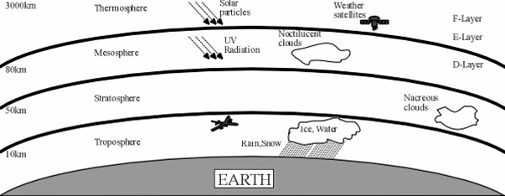
Questions: Answer in complete sentences
- What is weather? ___________________________________________ __________________________________________________________ __________________________________________________________
- What causes weather? _______________________________________ _________________________________________________________ _________________________________________________________
- In what layer of the earth’s atmosphere does most weather occur?
  - Stratosphere
  - Troposphere
  - Mesosphere
Weather Variables
The change in weather is described by a series of weather variables. These weather variables include Air Temperature, Air Pressure, Humidity, Wind Speed, Wind Direction, and Precipitation
Air Temperature-the amount of heat energy in the atmosphere at a place
Air Pressure- is the amount of force exerted by the air hitting a given surface area
Humidity- the amount of water vapor in the air
Wind Speed-the rate of moving air
Wind Direction- the direction that the wind blows FROM
Precipitation-failing moisture from clouds (Rain, Snow, Sleet, and Hail)
Scientists communicate weather in different locations using the station model.
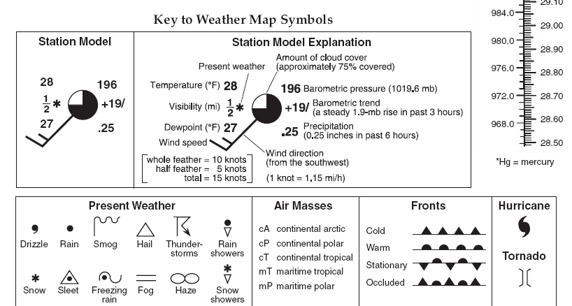
On the station model above identify the following weather variables:

- Temperature________⁰F
- Air Pressure_______mb
- Wind Speed_______ knots
- Wind Direction_______
Weather Variable | Definition | Units | Instrument
Air Temperature | The amount of heat energy in the atmosphere as a place | ⁰F (Fahrenheit) or  ⁰C (Celsius) | Thermometer  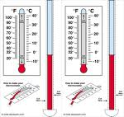
Air Pressure | The amount of force exerted by the air hitting a given surface area | millibars (mb) | Barometer  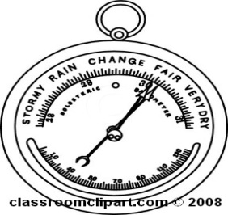
Humidity | The amount of water vapor in the air | Relative Humidity expressed in percent % | Sling Psychrometer
Wind Speed | Moving air | Knots or miles per hour (K or mph) | Anemometer  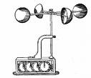
Wind Direction | The direction that the wind is blowing FROM | North, East, South, West | Wind Vane  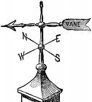
Precipitation | Forms of water that fall from clouds example: Rain, snow, sleet, hail, or freezing rain | Inches, or centimeters | Rain gauge  