Name ____________________ Date _____________
Heat Transfer
All substances are made up of small particles, which can be atoms or molecules, that are constantly moving. The faster the molecules are moving, the more energy they have. The total energy of motion in the particles of a substance is called thermal energy. Temperature is the average amount of energy of motion in each particle of a substance. It is a measure of how hot or cold a substance is. Temperature is one of the most important elements of weather.
Air temperature is usually measured with a thermometer. A thermometer is a thin glass tube with a bulb on one end that contains a liquid, usually mercury or colored alcohol. Thermometers work because liquids expand when they are heated and contract when they are cooled.
Temperature is measured in units called degrees. Oh the Celsius scale, the freezing point of pure water is 0°C and the boiling point of pure water is 100°C. On the Fahrenheit scale, the freezing point of water is 32°F and the boiling point is 212°F.
Heat refers to the energy transferred from a hotter object to a cooler one. Heat is transferred in three ways: radiation, conduction, and convection.
Radiation is the direct transfer of energy. The direct transfer of heat from one substance to another substance that it is touching is called conduction. Conduction works well in some solids, but not as well in fluids (liquids and gases). In fluids, molecules can move from place to place and take their heat with them. The transfer of heat by the movement of a fluid is called convection.
Radiation, conduction, and convection work together to heat the troposphere. Air near Earth's surface is warmed by conduction of heat from the surface to the air. Within the troposphere, heat is transferred mostly by convection. When the air near the ground is heated, the molecules have more energy and move faster. The molecules bump into one another and move farther apart, or become less dense. Cooler, denser air sinks, forcing the warmer, less dense air to rise. The upward movement of warm air and the downward movement of cool air form convection currents. Convection currents move heat throughout the troposphere.

Heat Transfer
Understanding Main Ideas
Label each picture with the type of heat transfer that it shows.

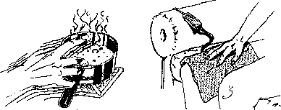
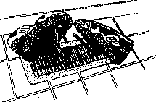

1.
4.
3.
2.

Answer the following questions in the spaces provided.
5. How is air temperature usually measured? _____________________
6. At what temperature on the Celsius scale does pure water freeze? At what temperature does it boil?
________________________________________________________________
7. Name the three -ways by which heat is transferred.__________________________
_______________________________________________________________________
8. How is heat transferred from the sun to Earth? ________________
9. Heat is moved through the troposphere mainly by _____________
Building Vocabulary
Fill in the blank to complete each statement.
10. The total energy of motion in the particles of a substance is called
______________________________________.
11. ______________________________ is the average amount of energy of motion in

the particles of a substance.

12. A(n) _________________________________is a thin glass tube with a bulb on one
end that contains a liquid, usually mercury or colored alcohol-
13. The energy transferred from a hotter object to a cooler one is referred to
as__________________.
14. The direct transfer of heat from one substance to another substance that it is touching is called ________________.
15. The transfer of heat by the movement of a liquid is called

