Chapter 4-1: What causes climate?

- What is the difference between weather and climate?

- What two things cause climate?

- List 4 things that affect temperature

- What are the 3 temperature zones? Color and Label the picture and key below
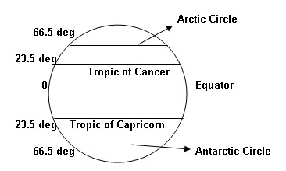

- How does altitude affect temperature?

- Compare Marine climates with Continental climates.

- What is an ocean current? List three main ocean currents.

- What is a monsoon?
- What two factors affect precipitation?

- What influences how much rain or snow will fall in an area?

- Draw a picture of the leeward and windward side of a mountain.

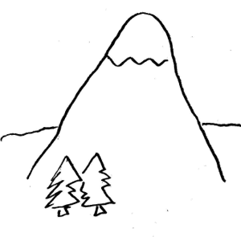

- What season is it when the Earth is farthest from the sun?

- The Earth has a tilt at what angle?

- How do the seasons in the Northern hemisphere compare with the seasons in the Southern hemisphere?

